**Skewness Kurtosis**

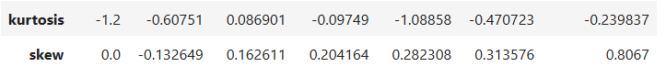

**Skewness**

ssc_p: -0.60751

Contains the negative values falls under the **Mean<Median<Mode** so it’s **(Negative)**

hsc_p: 0.086901

Contains the positive values falls under the **Mean = Median = Mode** so it’s **(Positive)**

degree_p:-0.09749

Contains the negative values falls under the **Mean<Median<Mode** so it’s **(Negative)**

etest_p:-1.08858

Contains the negative values falls under the **Mean<Median<Mode** so it’s **(Negative)**

mba_p:-0.470723

Contains the negative values falls under the **Mean<Median<Mode** so it’s **(Negative)**

salary:-0.239837

Contains the negative values falls under the **Mean<Median<Mode** so it’s **(Negative)**

**Kurtosis**

ssc_p: -0.132649

Contains the negative values **falls under < 3** so it’s (**Platykurtic**)

hsc_p: 0.162611

Contains the positive value **falls under = 3** so it’s (**Mesokurtic**)

degree_p: 0.204164

Contains the positive value **falls under = 3** so it’s (**Mesokurtic**)

etest_p: 0.282308

Contains the positive value **falls under = 3** so it’s (**Mesokurtic**)

mba_p: 0.313576

Contains the positive value **falls under > 3** so it’s (**Leptokurtic**)

salary: 0.8067

Contains the positive value **falls under > 3** so it’s (**Leptokurtic**)